ITC-6000

Assignment 3

August 1, 2020

**[Sunil Raj Thota]**

# Question 1

**Draft and explain in an MS Word document the proper sequence of activities in the design of a video rental database, or a similar product of your choice. The initial ERD for the video rental is shown below and in the chapter as Figure 9.9. Your design must support all rental activities, customer payment tracking, and employee work schedules, as well as track which employees checked out the videos to the customers.**

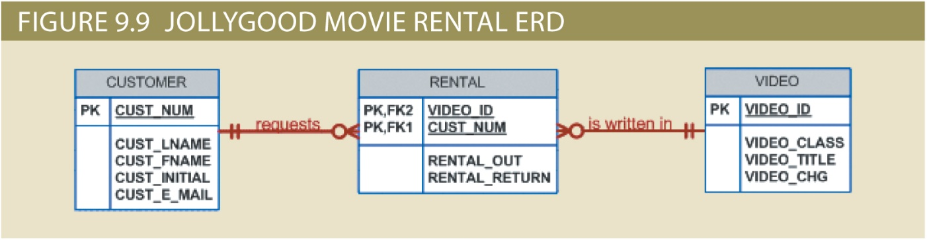

All objects (entities, attributes, relations, views, and so on) are defined in a data dictionary, which is used in synchronous with the normalization process to help eliminate data anomalies and redundancy problems. Clearly, many more attributes must be defined and the dependencies must be checked before the design can be implemented.

During this ER modelling process, the designer must:

* Define entities, attributes, primary keys, and foreign keys
* The foreign keys serve as the basis for the relationships among the entities
* Make decisions about adding new primary key attributes to satisfy end-user and/or processing requirements
* Make decisions about the treatment of composite and multivalued attributes
* Make decisions about adding derived attributes to satisfy processing requirements
* Make decisions about the placement of foreign keys in 1: 1 relationship
* Avoid unnecessary ternary relationships
* Draw the corresponding ER diagram and Normalize the entities
* Include all data element definitions in the data dictionary
* Make decisions about standard naming conventions
* Proper documentation is crucial to the successful completion of the design

**Normalization**:

It is a technique in which the analysts come to know about their model. It is used to validate their models. In this process a sequence of rules applied to logical data model or files and it checked that how well these files are formed. It basically helps to cross check the logical data models and verifies the entities. If it is found that entities are incorrectly represented then these entities are checked again and makes them correct. For the second normal form the first and basic requirement is that the model should be in the first normal form. The second requirement is that the data model must contain those entities which have the attributes which are dependent...

**Design of Video Rental Database:**

The below is the design of video rental database that includes the support of the employee, checkout which employee has processed the videos for the customers

* The video rental shop classifies movie titles according to their type: Comedy, Western, Classical, Science Fiction, Cartoon, Action, Musical, and New Release. Each type contains many possible titles, and most titles within a type are available in multiple copies
* The movie type classification is standard: not all types are necessarily in stock. The video rental shop does not necessarily order movies from all of the vendor list; some vendors on the vendor list are merely potential vendors from whom movies may be ordered in the future
* When the customer checks out a title, expected return date and time. Upon the return of rented titles, the clerk must be able to check quickly whether the return is late and to assess the appropriate late return fee
* The clerk must be able to check quickly whether or not the return is late and to assess the appropriate "late return" fee. This requirement is met by adding attributes such as expected return date, actual return date, and late Fees to the RENTAL entity
* Note that there is no need to add a new entity, nor do we need to create an additional relationship. Keep in mind that some requirements are easily met by including the appropriate attributes in the tables and by combining those attributes though an application program that enforces the business rule
* The store owner wants to be able to keep track of all employees work time and payroll data Here we must rate the entities: WORK SCHEDULE and WORK LOG. which will show the employee work schedule and the actual time worked, respectively. These entities will also help us generate the payroll report
* The video-store owner wants to be able to generate periodic revenue reports by title and by tape. The owner also wants to be able to generate periodic inventory reports and to keep track of titles on order
* As you design this database, remember that transaction and information requirements help drive the design by defining required entities, relationships, and attributes
* The overall design philosophy was to keep the design simple but also flexible for future enhancements

**Explanation:**

* Every movie is classified based on the type and the relationship between MOVIE and TYPE is N: 1
* One movie gets rented many times and the relationship between the MOVIE and RENTAL is 1: N
* Every customer needs to pay for the rental made and the relationship between CUSTOMER and RENTAL is 1: N
* Employee gathers details and writes about the rental made and the relationship between EMPLOYEE and RENTAL IS 1: N
* Every employee sign work of and the relationship between the EMPLOYEES and WORK LOG 1: N
* Every schedule of the Employee gets enters and the relationship between the EMPLOYEES and SCHEDULE is 1: N
* Every movie is recorded in the order table and the relationship between MOVIE and ORDER is 1: N
* Every order writes to an employee and the relationship between ORDER and EMPLOYEE is N: 1
* 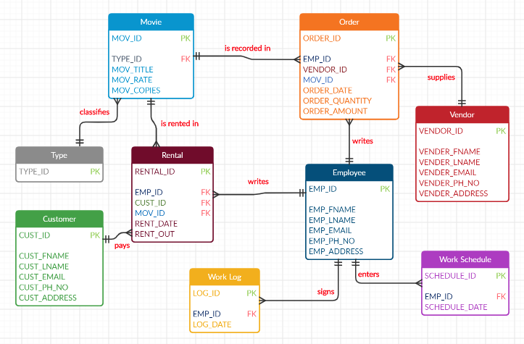Every order gets supplied by the vendor and the relationship between ORDER and VENDOR is N: 1